Try to map the ERD and then create DB with the following Constraints:
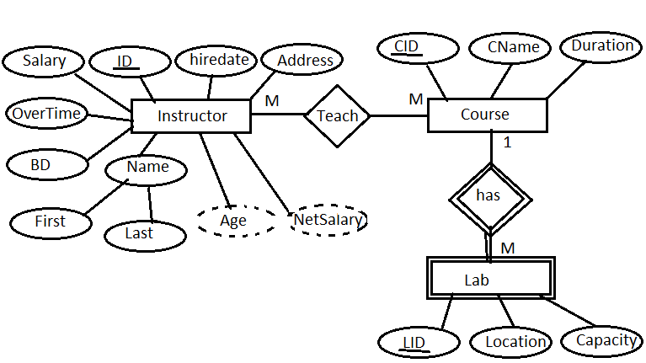
- All Ids are Identity
- All Foreign keys are not identity
- All foreign keys have cascade rule on delete and update
- Age and Netsalary are calculated attributes but it will be on instructor table creation
- Netsalary=salary+overtime
- Age=current year – birthdate year
- Address has only cairo or alex value
- All salaries in the range from 1000 to 5000
- Salary has a default value = 3000
- Overtime is unique
- Capacity of each lab under 20 seats
- Lab is weak entity
- Hiredate has a default value= current system data
- Duration of each course is unique

